A

Mini-Project Report on

## AI Powered Interactive Workout Assistant for Form Detection & Correction

Submitted in partial fulfillment of the requirements for the degree of

BACHELOR OF ENGINEERING

IN

### Computer Science & Engineering

### (Artificial Intelligence & Machine Learning)

by

Siddhesh Dige (21106017)

Abhishek Bapat (21106008)

Tanisha Chitnis (21106003)

Shlok Dalvi (21106012)

Under the guidance of

## Prof. Taruna Sharma



### Department of Computer Science & Engineering

### (Artificial Intelligence & Machine Learning)

**A. P. Shah Institute of Technology**

**G. B. Road, Kasarvadavali, Thane (W)-400615**

**University Of Mumbai**

**2023-2024**

## A. P. SHAH INSTITUTE OF TECHNOLOGY

## CERTIFICATE

This is to certify that the project entitled “**AI Powered Interactive Workout Assistant for Form Detection & Correction”** is a bonafide work of Siddhesh Dige (21106017), Abhishek Bapat (21106008), Tanisha Chitnis (21106003), Shlok Dalvi (21106012) submitted to the University of Mumbai in partial fulfillment of the requirement for the award of **Bachelor of Engineering** in **Computer Science & Engineering (Artificial Intelligence & Machine Learning).**

| ________________ | _______________ |
| --- | --- |
| Prof. Taruna Sharma | Dr. Jaya Gupta |
| Mini Project Guide | Head of Department |

## 

## A. P. SHAH INSTITUTE OF TECHNOLOGY

## Project Report Approval

This Mini project report entitled “**AI Powered Interactive Workout Assistant for Form Detection & Correction*”*** by **Siddhesh Dige, Abhishek Bapat, Tanisha Chitnis, and Shlok Dalvi**is approved for the degree of ***Bachelor of Engineering*** in ***Computer Science &Engineering***, (AIML) ***2023-24***.

##### External Examiner:

##### Internal Examiner:

Place: APSIT, Thane

Date:

**Declaration**

##### We declare that this written submission represents my ideas in my own words and where others' ideas or words have been included, I have adequately cited and referenced the original sources. I also declare that I have adhered to all principles of academic honesty and integrity and have not misrepresented or fabricated or falsified any idea/data/fact/source in my submission. I understand that any violation of the above will be cause for disciplinary action by the Institute and can also evoke penal action from the sources which have thus not been properly cited or from whom proper permission has not been taken when needed.

| Siddhesh Dige | Abhishek Bapat | Tanisha Chitnis | Shlok Dalvi |
| --- | --- | --- | --- |
| (21106017) | (21106008) | (21106003) | (21106012) |

#### ABSTRACT

The AI Gym Assistant Machine Learning Project represents a cutting-edge initiative bridging the domains of artificial intelligence and fitness technology. This project endeavors to redefine individual fitness journeys through the application of sophisticated machine learning algorithms and the utilization of OpenCV, a powerful computer vision library. Building upon the legacy of AI development, the project envisions a dynamic virtual assistant capable of delivering tailored exercise recommendations and providing instantaneous feedback. OpenCV integration empowers the assistant to analyze real-time video data, enabling precise form assessment and exercise adjustment. Furthermore, the AI companion extends its impact beyond the gym, offering comprehensive exercise report for the user. This abstract encapsulates the project's mission to enhance physical fitness and overall well-being, presenting a vision of a future where AI-driven fitness companions stand as integral partners in our journey towards a healthier lifestyle.

**Keywords**: OpenCV, AI, Gym

**Index**

| Index | | | Page no. |
| --- | --- | --- | --- |
| Chapter-1 | | |  |
|  | Introduction | | 1 |
|  |  |  |  |
| Chapter-2 | | |  |
|  | Literature Survey | | 3 |
|  | 2.1 | History | 4 |
|  | 2.2 | Review | 5 |
|  |  |  |  |
| Chapter-3 | | |  |
|  | Problem Statement | | 8 |
|  |  |  |  |
| Chapter-4 | | |  |
|  | Experimental Setup | | 10 |
|  | 4.1 | Hardware setup | 11 |
|  | 4.2 | Software Setup | 11 |
|  |  |  |  |
| Chapter-5 | | |  |
|  | Proposed system and Implementation | | 12 |
|  | 5.1 | Block Diagram of proposed system | 13 |
|  | 5.2 | Description of Block diagram | 13 |
|  | 5.3 | Implementation | 15 |
|  | 5.4 | Advantages | 16 |
|  | 5.5 | Description | 16 |
| Chapter-6 | | |  |
|  | Conclusion | | 18 |
|  |  |  |  |
| References | | | 20 |
|  |  | Research Paper | 21 |

# CHAPTER 1 INTRODUCTION

### INTRODUCTION

In recent years, the integration of artificial intelligence (AI) and fitness has ushered in a new era of personalized exercise guidance and training. This project, centered around the development of an AI Gym Assistant, represents a significant leap forward in leveraging machine learning algorithms to enhance the fitness journey for individuals across diverse demographics. Combining the power of AI with the familiarity of gym settings, this endeavor aims to revolutionize how we approach and optimize our workouts. The concept of a virtual AI gym assistant stems from a rich history of technological advancements in both AI and fitness-related applications. With roots in early AI assistants like ELIZA in the 1960s, which marked the inception of natural language interactions with computers, and the proliferation of personal digital assistants (PDAs) in the 1980s and 1990s, the stage was set for the convergence of AI and personal devices. The new millennium brought forth chatbots, paving the way for more interactive and intuitive user interfaces, while the 2010s witnessed the transformative integration of wearable technology and fitness apps, democratizing access to expert fitness guidance.

This project endeavors to build upon this legacy, taking inspiration from the trajectory of AI's evolution. By fusing cutting-edge machine learning techniques with real-time data processing, the AI Gym Assistant aspires to become a dynamic, interactive companion for individuals seeking to optimize their fitness routines.

Real-time feedback loop will enable the AI Gym Assistant to provide instant corrections, form adjustments, and exercise modifications, ensuring that users perform each movement with precision and safety. The result is a truly personalized workout experience, surpassing the capabilities of traditional, static exercise routines. Beyond the confines of the gym, this AI-driven companion has the potential to extend its influence into broader realms of wellness. This holistic approach reaffirms the project's commitment to not only enhancing physical fitness but also nurturing overall well-being. As we embark on this innovative endeavor, it is essential to recognize that this project builds on the foundation of extensive research and development in AI, machine learning, and fitness technology. With a forward-looking perspective, this AI Gym Assistant project seeks to redefine how we engage with our personal fitness goals, offering a glimpse into a future where AI-driven fitness companions become indispensable partners in our pursuit healthier, more vibrant life.

# CHAPTER 2 LITERATURE SURVEY

#### LITERATURE SURVEY

###### 2.1-HISTORY

#### In the dynamic field of artificial intelligence, the journey towards a virtual AI gym assistant represents a remarkable fusion of cutting-edge technologies and a growing emphasis on personalized health and fitness. Building on the foundation laid by early pioneers like ELIZA, whose conversational abilities in the 1960s were groundbreaking, subsequent decades saw a steady progression in AI capabilities. The advent of personal digital assistants (PDAs) in the 1980s and 1990s, exemplified by devices like Apple's Newton and the Palm Pilot, introduced the concept of AI companionship in our daily lives, albeit in a rudimentary form. The dawn of the new millennium ushered in chatbots, revolutionizing user interactions on websites and paving the way for more intuitive interfaces. As the 2010s unfolded, a seismic shift occurred with the integration of wearable tech and fitness apps, giving rise to virtual personal trainers that not only prescribed exercises but also meticulously tracked progress, effectively democratizing access to professional fitness guidance. Concurrently, AI and natural language processing evolved in tandem, endowing virtual assistants with an unprecedented level of conversational fluency. Devices like Amazon Echo and Google Home transformed our living spaces into smart, AI-assisted environments, seamlessly integrating virtual assistants into the fabric of our daily routines. In parallel, the healthcare and fitness industries experienced a paradigm shift with AI algorithms playing an increasingly prominent role in areas such as personalized dietary planning, real-time health monitoring, and even early detection of potential health issues. Now, in this hypothetical post-2021 landscape, the emergence of a virtual AI gym assistant represents a culmination of these trends. Beyond just a repository of exercises, it becomes an interactive, personalized coach, capable of adapting to individual needs, preferences, and progress. Augmented reality (AR) and virtual reality (VR) technologies, with their immersive capabilities, elevate the workout experience to an entirely new level, providing users with a sense of engagement and presence previously unattainable through conventional means. Additionally, integration with wearables allows for a seamless flow of data, enabling the AI assistant to provide real-time feedback, correct form, and make on-the-fly adjustments, creating a truly dynamic and responsive training environment. Beyond the confines of the gym, this virtual AI companion could extend its influence into broader realms of wellness, leveraging its understanding of individual health metrics, dietary habits, and sleep patterns to offer comprehensive recommendations for a balanced and sustainable lifestyle.

#### 2.2-LITERATURE REVIEW

#### Learning OpenCV--- Computer Vision with the OpenCV Library (Bradski, G.R. et al.; 2008)

#### The OpenCV offers a free and easy way for people to get started in computer vision. It creates a way to grow the developer community and encourages innovation in a space where many of the algorithms and methods for computer vision systems are locked behind the corporate and R&D laboratory doors. The textbook explains how to install the software and gets you started with simple examples with single images and then onto video, and working with the all important graphical user interface (GUI). The textbook addresses the education market by providing an extensive set of exercises at the end of each chapter. The degree of difficulty for the exercises is not entirely uniform, but it is evident that the authors have been thoughtful in their choice of exercises.

#### Pose Estimation from corresponding point data (R.M. Haralick; H. Joo; C. Lee; X. Zhuang; V.G. Vaidya; M.B. Kim; 1989)

#### Solutions for four different pose estimation problems are presented. Closed-form least-squares solutions are given to the over constrained 2D-2D and 3D-3D pose estimation problems. A globally convergent iterative technique is given for the 2D-perspective-projection-3D pose estimation problem. A simplified linear solution and a robust solution to the 2D-perspective-projection-2D-perspective-projection pose-estimation problem are also given. Simulation experiments consisting of millions of trials with varying numbers of pairs of corresponding points and varying signal-to-noise ratios (SNRs) with either Gaussian or uniform noise provide data suggesting that accurate inference of rotation and translation with noisy data may require corresponding point data sets with hundreds of corresponding point pairs when the SNR is less than 40 dB. The experimental results also show that the robust technique can suppress the blunder data which come from outliers or mismatched points.

#### Safe-Control-Gym: A Unified Benchmark Suite for Safe Learning-Based Control and Reinforcement Learning in Robotics (Zhaocong Yuan; Adam W. Hall; Siqi Zhou; Lukas Brunke; Melissa Greeff; Jacopo Panerati; Angela P. Schoelli; 2022)

#### In recent years, both reinforcement learning and learning-based control—as well as the study of their safety, which is crucial for deployment in real-world robots—have gained significant traction. However, to adequately gauge the progress and applicability of new results, we need the tools to equitably compare the approaches proposed by the controls and reinforcement learning communities. Here, we propose a new open-source benchmark suite, called safe-control-gym, supporting both model-based and data-based control techniques. We provide implementations for three dynamic systems—the cart-pole, the 1D, and 2D quadrotor—and two control tasks—stabilization and trajectory tracking. We propose to extend OpenAI's Gym API—the de facto standard in reinforcement learning research—with (i) the ability to specify (and query) symbolic dynamics and (ii) constraints, and (iii) (repeatedly) inject simulated disturbances in the control inputs, state measurements, and inertial properties. To demonstrate our proposal and to bring research communities closer together, we show how to use safe-control-gym to quantitatively compare the control performance, data efficiency, and safety of multiple approaches from the fields of traditional control, learning-based control, and reinforcement learning.

#### Robust Intelligent Posture Estimation for an AI Gym Trainer using Mediapipe and OpenCV(Venkata Sai P Bhamidipati, Ishi Saxena, Mrs. D. Saisanthiya;2023)

#### The research presents a robust posture estimation system using Mediapipe and OpenCV for accurate workout technique analysis and injury prevention. Mediapipe provides pre-trained models for human posture estimation, while OpenCV offers image and video processing functions. The system captures the user's video feed, detects body landmarks with Mediapipe, and calculates angles with OpenCV to analyze posture. It provides real-time feedback and suggests corrective measures. The system focuses on bicep curls but can be tested on various exercises. It performs well in different lighting conditions, is robust to occlusions, and background clutter. Deployable as an AI Gym Trainer, it helps users improve form, technique, and reduces injury risks.

#### AI-Based Workout Assistant and Fitness Guide (Gourangi Taware; Reena Kharat; Pratik Dhende; Prathamesh Jondhalekar; Rohit Agrawal; 2022)

#### Health and Fitness play a vital role in our day-today life. This can be attained in many ways of which exercising is one. Performing exercise can help us maintain very good health, only if carried out properly and in a defined manner, else the repercussions may have adverse effects on our body. To tackle this issue, we have created a system that keeps track of body movements and provides us with the number of repetitions performed, if performed within the foundation of the model. Our system also provides audio instruction to the user when performing the exercise inappropriately, and with the assistance of the user's physical measurements and his/her diet, the system is able to keep track of the user's calorie intake and recommends a certain amount of calorie intake to be followed in order to achieve normal Body Mass Index in order to stay fit. The proposed system uses Mediapipe Pose Estimation Model to track body moments while performing the exercise.

# CHAPTER 3

# Problem Statement

#### Problem Statement

People often have difficulty tracking their reps and sets, which can lead to inaccurate measurements of progress and increased risk of injury. It can be difficult for people to correct their form without a qualified personal trainer. An AI gym assistant with the features of reps and sets tracker and form correction could address these challenges by: Using computer vision to track the user's movements and provide real-time feedback on their form.

Here are some specific examples of how AI could be used to implement these features:

Reps and sets tracker: The AI could use computer vision to track the user's movements and count the number of reps and sets they complete. This could be done using a webcam or a mobile device's camera.

Form correction: The AI could use computer vision to analyze the user's movements and provide real-time feedback on their form. This could be done by comparing the user's movements to a track of correct form examples.

Voice Assistant: The gym assistant app includes a voice assistant feature that allows users to interact with the app using voice commands. A user can start/stop his desired exercise by giving voice commands.

Report Generator: The app also features a report generator that automatically generates workout reports based on user activity. The report generator analyzes the user's workout data, such as repetitions, and form quality, and generates a report that can help users track their progress, identify areas for improvement, and stay motivated in their fitness journey.

Form Detection: The gym assistant app includes a form detection feature that uses a pose landmarker model, angle between joints, and logic to analyze the user's exercise form in real-time. This feature provides feedback to the user on their form, helping them perform exercises correctly and reduce the risk of injury.

# CHAPTER 4

# Experimental Setup

#### Experimental Setup

#### 4.1 Hardware Setup

* Operating System- Windows version 11

#### 4.2 Software Setup

#### Python version 3.12.0

#### Jupyter Notebook

#### OpenCV

#### Numpy

#### Pandas

#### Media-pipe

#### Scikit-learn

* Streamlit
* Whisper Model
* SpeechT5

# CHAPTER 5

# Proposed System & Implementation

#### Proposed system & Implementation

#### 5.1 Block diagram of proposed system

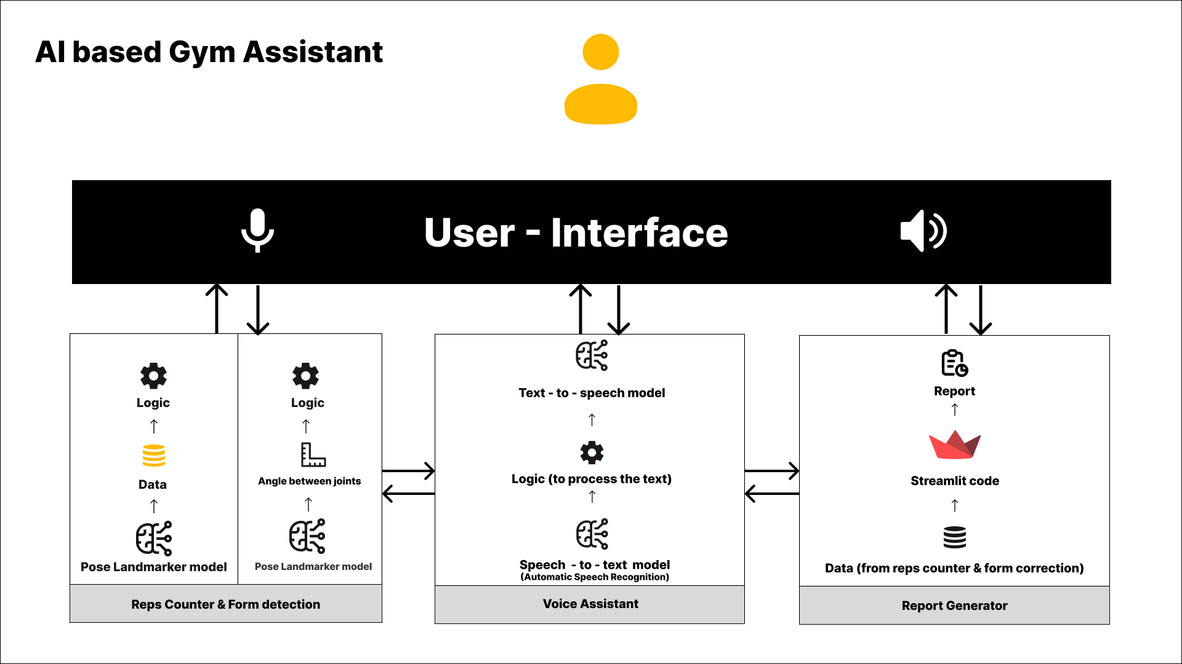

#### Fig 5.1

#### 5.2 Description of block diagram

* 5.2.1 User Interface - A user friendly interface which provides steps for performing exercises properly and also provides the live video feed while performing exercise. We have implemented Streamlit which is a Python framework for GUI.
* 5.2.2 Reps counter & Form detection - The reps counter and form detection feature in the gym assistant app utilizes a pose landmarker model, angle between joints, data and logic to track and analyze the user's movements during exercises.
* Pose landmarker model- This is a pre-trained model in the mediapipe library which has the record of all joint angles and poses of the human body. This model proves helpful in extracting accurate joint angles thus extracting valuable data points.
* Angle between joints- Once the pose landmarker model has detected the key points on the user's body, the app calculates the angles between specific joints (e.g., elbow, knee, hip) to determine the user's body posture and movement.
* Logic- The app uses predefined logic or rules to interpret the angle measurements and determine if the user is performing the exercise correctly.
* Data- The pose landmarker model extracts data such as the coordinates of key points on the user's body, including joints and limbs, in real-time. This data provides information about the user's body posture and movement during exercises.
* Voice Assistant-The gym assistant app includes a voice assistant feature that allows users to interact with the app using voice commands. A user can start/stop his desired exercise by giving voice commands.
* Whisper-large (Automatic speech recognition) **:** Whisper is a pre-trained model for automatic speech recognition (ASR) and speech translation. Trained on 680k hours of labelled data. Whisper was proposed in the paper Robust Speech Recognition via Large-Scale Weak Supervision by Alec Radford et al from OpenAI.
* SpeechT5 (text –to- speech) **:** This model was introduced in SpeechT5: Unified-Modal Encoder-Decoder Pre-Training for Spoken Language Processing by Junyi Ao, Rui Wang, Long Zhou, Chengyi Wang, Shuo Ren, Yu Wu, Shujie Liu, Tom Ko, Qing Li, Yu Zhang, Zhihua Wei, Yao Qian, Jinyu Li, Furu Wei.
* Report Generator- The system also features a report generator that automatically generates workout reports based on user activity. The report generator analyzes the user's workout data, such as repetitions, and form quality, and generates a report that can help users track their progress, identify areas for improvement, and stay motivated in their fitness journey.
* Data from Reps Counter and Form Correction: The report generator collects data from the reps counter and form correction features, including information on the number of repetitions performed, exercise form quality, and any corrective measures suggested. This data is used to provide insights into the user's workout performance.
* Streamlit Code: The report generator uses Streamlit, a Python library for building web applications, to generate the user interface for the workout reports. Streamlit allows for the creation of interactive and customizable reports, making it easy for users to view and analyze their workout data.
* Report Generation: Based on the collected data and Streamlit code, the report generator creates a detailed workout report for the user. The report includes information on the user's workout performance, including metrics such as number of repetitions and sets, and exercise-specific details. The report is designed to be easy to understand and provides actionable insights for improving workout effectiveness.

#### 5.3 Implementation

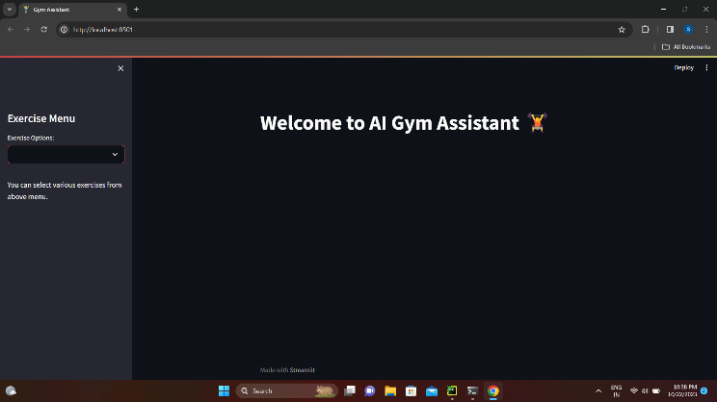 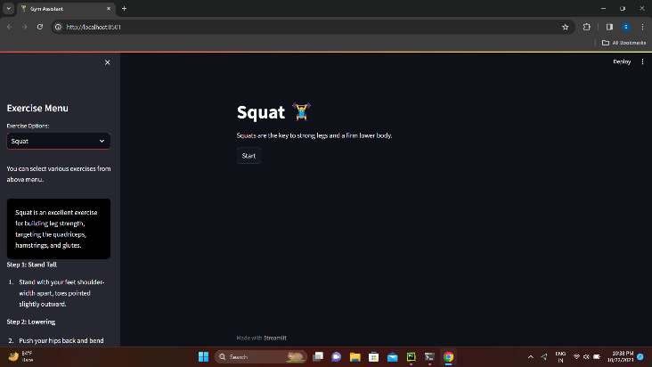

#### Fig 5.2 Fig 5.3

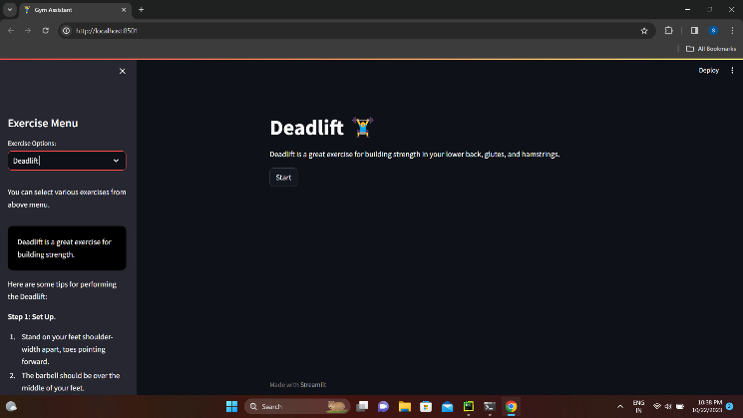 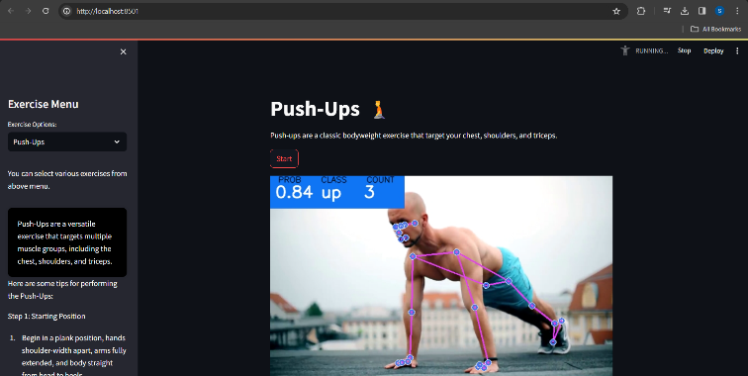

#### Fig 5.4 Fig 5.5

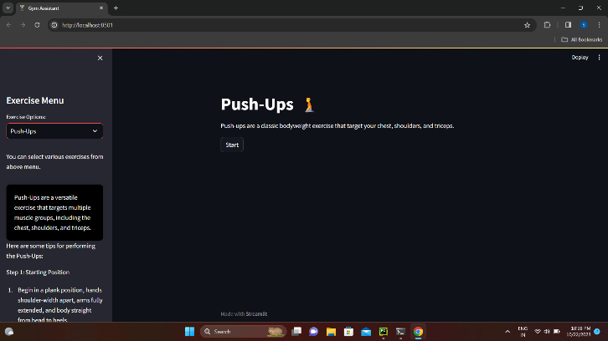 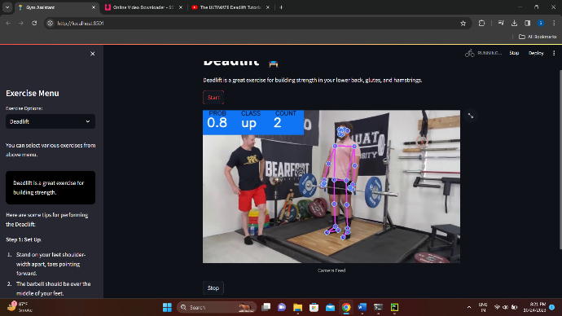

Fig 5.6 Fig 5.7

#### 

#### 5.4 Advantages :

1. **Progress Tracking**- The assistant keeps track of users’ workout progress reps and sets.
2. **No trainer required-** As the entire system is using computer vision there’s no need for an actual gym trainer to monitor the form and repetitions.
3. **Cost effective-** As the system is AI based , there is no hardware or operational costing required for the same. The system proves more efficient and reliable with respect to finances.

**5.5 Description :**

AI Based Gym Assistant is a project built with vision to help people carry out their workout easily and efficiently who cannot go to gym.

So to build this project we first off all collected our own data of various workouts for e.g. Pushups, deadlift, squats and bicep-curl. Then we have to train a model to classify the current position of the person which can further support the logic of reps and sets counter. So to train the model we first off all need data of body points according to the body position (landmark points). To get the body landmark points we need to feed our workout data in a pose landmarker model which will give us body points.

We used mediapipe’s pose estimation deep learning model to extract the body landmark points. We fed the pose estimation model with our data and we got the body points according to the position of the body. So to do this we created a function using OpenCV which can only record the body points when we press any key on keyboard, we created two classes ‘up’ and ‘down’ and pressed a particular key when the position was up or down due to which we got our data we needed to train the classification model.

We stored the data in a CSV file so that we can use it easily. Then for training the classification model we first processed the data using pandas library, we splitted the data into training and testing and defined the inputs and corresponding outputs because it was going to be a classification model (supervised learning).

Then we decided on some algorithms like logistic regression, random forest classifier, SVM, and gradient boosting. When we trained the model we found out that the random forest classifier was having highest precision score, accuracy score and recall score so we decided to go with random forest classifier. Using this method we trained models for deadlift, pushups, bicep-curl and squat. Then we tested the model on test data. It was working fine so we dumped the model weights in a pickle file. So till now our machine learning part was over.

Now we need to create a good UI for users to access the project. So we started making a good and simple UI using streamlit, we were using streamlit because streamlit is a python based framework which makes it easy to deploy models without learning extra front-end concepts.

We made a simple and good looking UI which has a home page, sidebar. Sidebar consists of an exercise menu which consists of exercises and selecting any exercise will lead you to a new page. For each page we created a start button which users can click to start their camera when starting workout, we wrote extensive functions to access the user's camera using OpenCV and for reps and sets counter which can track users progress, and now our project is complete we just need to carry out some test cases.

So we carried out test cases and the project was running perfectly well.

**Chapter 6**

**Conclusion**

**6. Conclusion**

In conclusion, the AI-based gym assistant leveraging technologies like MediaPipe and OpenCV represents a significant leap forward in revolutionizing fitness training. By seamlessly integrating computer vision and machine learning, this innovative system empowers users with real-time, accurate feedback on their exercise form. The precise detection of exercises such as bicep curls, push-ups, deadlifts, and squats not only enhances safety but also facilitates more effective workouts.

Through the utilization of state-of-the-art algorithms, this gym assistant ensures that users receive personalized guidance, helping them optimize their fitness routines. The visual feedback provided by the system serves as a valuable tool for both beginners and seasoned fitness enthusiasts, promoting proper technique and minimizing the risk of injury.

Moreover, the adaptability of this AI-based assistant allows for a dynamic range of exercises to be incorporated into its repertoire, ensuring a comprehensive fitness experience. Its potential for continuous improvement and expansion of exercise recognition capabilities further cements its position as a cutting-edge solution in the fitness industry.

Ultimately, this AI-based gym assistant not only signifies a technological milestone but also embodies a commitment to enhancing the well-being and performance of individuals pursuing their fitness goals. As this technology continues to evolve, it holds the promise of transforming the way we approach fitness training, making it more accessible, precise, and personalized than ever before.

.

# References

[1] Zelinsky, Alex. "Learning OpenCV---Computer vision with the OpenCV library (Bradski, GR et al.; 2008)[On the Shelf]." IEEE Robotics & Automation Magazine 16, no. 3 (2009): 100-100.

[2] Haralick, Robert M., Hyonam Joo, Chung-Nan Lee, Xinhua Zhuang, Vinay G. Vaidya, and ManBae Kim. "Pose estimation from corresponding point data." IEEE Transactions on Systems, Man, and Cybernetics 19, no. 6 (1989): 1426-1446 [3] https://mpeg.chiariglione.org/who-we-are

[3] Yuan, Zhaocong, Adam W. Hall, Siqi Zhou, Lukas Brunke, Melissa Greeff, Jacopo Panerati, and Angela P. Schoellig. "Safe-control-Gym: A unified benchmark suite for safe learning-based control and reinforcement learning in robotics." IEEE Robotics and Automation Letters 7, no. 4 (2022): 11142-11149.

[4] Saravanan, Renuka, and Pothula Sujatha. "A state of art techniques on machine learning algorithms: a perspective of supervised learning approaches in data classification." In 2018 Second international conference on intelligent computing and control systems (ICICCS), pp. 945-949. IEEE, 2018.

[5] Taware, Gourangi, Reena Kharat, Pratik Dhende, Prathamesh Jondhalekar, and Rohit Agrawal. "AI-based Workout Assistant and Fitness guide." In 2022 6th International Conference On Computing, Communication, Control And Automation (ICCUBEA, pp. 1-4. IEEE, 2022.

[6] Scikit-Learn: <https://scikit-learn.org/stable/user_guide.html>

[7] OpenCV: <https://opencv.org/get-started/>

[8] MediaPipe: <https://developers.google.com/mediapipe>

[9] Numpy: <https://numpy.org/doc/stable/user/absolute_beginners.html>